Nepal Engineering College
Center for Advanced Studies
Imadol Lalitpur
Assessment Spring Semester 2006

Program: BE Semester: Spring
Time: 2hrs Year : 2006
Full Marks: 100 PM: 50
Engineering Math-III
Attempt all questions
1. a) Show that 7
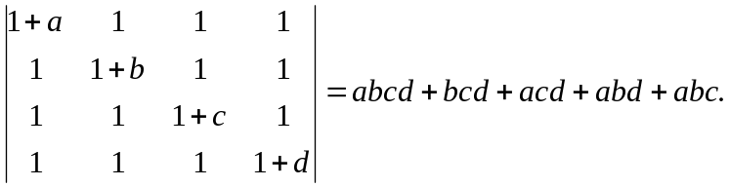
b) Check the consistency of the equation then solve by using Gauss if possible. * Elimination method 8
10x - y + 2z = 4
x +10y - z = 3
2x +3y + 20z = 7
2 a) i) Let V = R³ be a vector space 4
W₁= 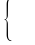(x₁ 0₁ z) : x, z R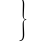
W₂ = 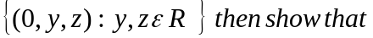
W₁ ∩ W₂ is a subspace of γ
ii) Check the linearity of 4
T : R²→ R³ defined by
T (x,y) = (x, y, xy)
b) Find the eigen value of & corresponding eigen vector of the matrix 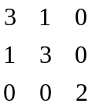 7
3 a) State and prove p - test 7
Or
Discuss the convergence and divergence of the series 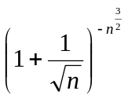 7
b) Find interval, center and radius of convergence of the series 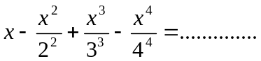 8
4 a) Find the Fourier series of
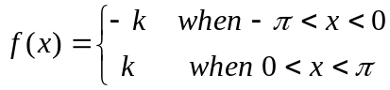
and show that
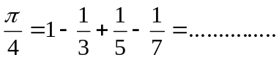
b) Find the Fourier cosine and sine series of the function
f(x) = x² for 0 <x < L 7
5 a) Find directional derivative of the function 7
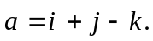
b) Find a unit vector normal to the surface
xy³z² = 4 at (-1 , -1, 2) and prove that if 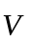be a vector valued function which is continuous differentiable 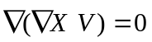 8
6. a) Show that the value under integral sign is exact and evaluate the integral
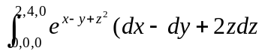 7
Or
By using Green's theorem evaluate
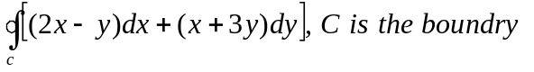of the curve x² + 4y² = 4 in the anticlockwise direction.
b) Evaluate 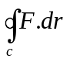 by using stokes theorem where
8
7. Attempt all the question 2*5
a) Find the rank of 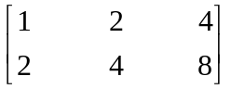
b) Check the linearly dependent and independent and independent of (1,0,0), (0,1,0) and (0,0,1)
c) Check the convergence & divergence of 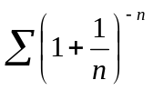
d) Prove that the product of two odd function is even function.
e) Find the divergence of 